**Hackathon Project Phases Template** for the **AutoSage App** project.

# Hackathon Project Phases Template

**Project Title:**

**AI Study Planner(studbud)**

**Team Name:**

**United minds**

**Team Members:**

* MARIPEDDI NAVYA
* MAHARAJU SRIHITHA
* GUMPARTHI MANIBINDHU SRIMAYEE
* MUDUTHAPALLY MEGHANA

## Phase-1: Brainstorming & Ideation

**🎯 Objective:**

Develop an **AI-powered study planner** that helps students create personalized study plans based on their goals, subjects, strengths, weaknesses, and preferences.

**📝 Key Points:**

1. **Problem Statement:**

* Students struggle with **time management** and **personalized study strategies**.
* Lack of **smart recommendations** based on learning preferences and available time.
* No **centralized platform** to provide study materials, schedules, and insights.

**2 .proposed Solution:**

* A **Generative AI-powered study planner** using **Gemini Flash API**.
* Generates **customized study schedules** based on user input.
* Provides **YouTube recommendations**, **PDF resources**, and **study strategies**

**3.Target Users:**

* Engineering, Pharmacy, Arts, Commerce, Medical, and Science students.
* Exam aspirants (JEE, NEET, UPSC, etc.).
* Anyone needing a structured **study plan generator**.

**4.Expected Outcome:**

* A **fully functional AI-powered study planner** with **customized study plans** and **extra learning resources**.

## Phase-2: Requirement Analysis

**Objective:**

Define the **technical and functional requirements** for StudBud.

**Key Points:**

1. **Technical Requirements:**

* 1. Programming Language: **Python**

○ Backend: **Google Gemini Flash API**

○ Frontend: **Streamlit Web Framework**

○ Database: **Not required initially (API-based queries)**

**1.Functional Requirements:**

* Generate **custom study plans** based on subjects & time availability.
* AI-powered **study strategy recommendations**.
* **Time-tracking & reminders for study sessions.**

**2. Constraints & Challenges:**

* Handling **API rate limits** and optimizing API calls.
* Ensuring **accurate AI-generated study plans**.
* Designing a **user-friendly UI for navigation**.

## Phase-3: Project Design

**Objective:**

Develop the architecture and user flow of the application.

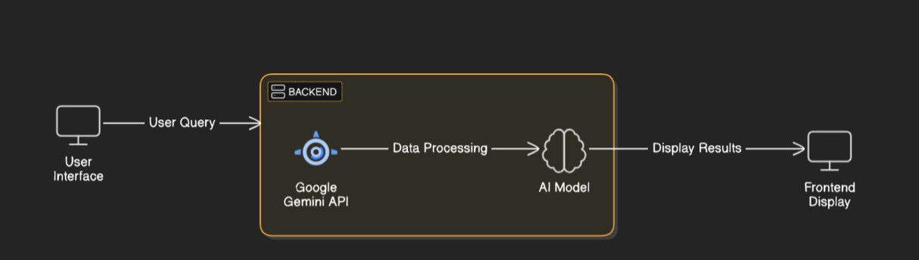

**Key Points:**

1. **System Architecture:**

* 1. User inputs **study preferences** (subjects, time, goals).

○ AI **processes the query** using **Gemini API**.

○ The **frontend displays** the study plan **visually**.

1. **User Flow:**

* 1. Step 1: User logs in and enters study requirements.

○ Step 2: AI generates a **personalized study plan**.

○ Step 3: User can **track progress** and receive **reminders**.

1. **UI/UX Considerations:**

* 1. **Simple & clean interface (Streamlit).**

○ **Dark & light mode** for better user experience.

**Simple & clean interface** (Streamlit)

## Phase-4: Project Planning (Agile Methodologies)

**Objective:**

Break down development tasks for efficient completion.

|  |  |  |  |  |  |  |  |
| --- | --- | --- | --- | --- | --- | --- | --- |
| **Sprint** | **Task** | **Priority** | **Duration** | **Deadline** | **Assigned To** | **Dependencies** | **Expected Outcome** |
| Sprint 1 | **Setup & API Integration** | 🔴 High | 6 hours | End of Day 1 | Member 1 | Google API Key, Python, Streamlit | AI API connection established |
| Sprint 1 | **Frontend UI Design** | 🟡 Medium | 2 hours | End of Day 1 | Member 2 | API response format | UI with login & input fields |
| Sprint 2 | **Study Plan Generation** | 🔴 High | 3 hours | Mid-Day 2 | Member 1 & 2 | AI model integrated | AI-generated study plan |
| Sprint 2 | **Error Handling & Debugging** | 🔴 High | 1.5 hours | Mid-Day 2 | Member 1 & 4 | API logs, UI inputs | Stable AI model output |
| Sprint 3 | **Testing & UI Enhancements** | 🟡 Medium | 1.5 hours | Mid-Day 2 | Member 2 & 3 | API response | Responsive UI |
| Sprint 3 | **Final Deployment** | 🟢 Low | 1 hour | End of Day 2 | Entire Team | Fully working model | Project ready for demo |

## Phase-5: Project Development

**Objective:**

Implement core features of studbud

**Key Points:**

1. **Technology Stack Used:**

* 1. **Frontend:** Streamlit

○ **Backend:** Google Gemini Flash API

○ **Programming Language:** Python

1. **Development Process:**

* 1. Implement **API key authentication** and **Gemini API integration**.

○ **Develop AI-based study plan logic**

1. **Challenges & Fixes:**

* 1. **Challenge:** API **rate limits** ⏩ **Fix:** Optimize API queries.

○ **Challenge: Slow response time ⏩ Fix: Caching for commonly requested topics.**

## Phase-6: Functional & Performance Testing

**Objective:**

Ensure that the AutoSage App works as expected.

|  |  |  |  |  |  |
| --- | --- | --- | --- | --- | --- |
| **Test Case ID** | **Category** | **Test Scenario** | **Expected Outcome** | **Status** | **Tester** |
| TC-001 | Functional  Testing | Query "Best budget cars under ₹10 lakh" | Relevant budget cars should be displayed. | ✅ Passed | Tester 1 |
| TC-002 | Functional  Testing | Query "Motorcycle maintenance tips for  winter" | Seasonal tips should be provided. | ✅ Passed | Tester 2 |
| TC-003 | Performance  Testing | API response time under  500ms | API should return results quickly. | ⚠ Needs Optimization | Tester 3 |
| TC-004 | Bug Fixes & Improvements | Fixed incorrect API responses. | Data accuracy should be improved. | ✅ Fixed | Develop er |
| TC-005 | Final Validation | Ensure UI is responsive across devices. | UI should work on mobile & desktop. | ❌ Failed - UI broken on mobile | Tester 2 |
| TC-006 | Deployment  Testing | Host the app using  Streamlit Sharing | App should be accessible online. | 🚀 Deployed | DevOps |

## Final Submission

1. **Project Report Based on the templates**
2. **Demo Video (3-5 Minutes)**
3. **GitHub/Code Repository Link**
4. **Presentation**

**🚀 Summary**

🔹 **StudBud** is an **AI-powered study planner** for students of **all disciplines**.  
🔹 Uses **Gemini API** to generate **personalized study plans**.  
🔹 Provides **PDFs, YouTube links, and Drive materials** for extra learning.  
🔹 Features **time-tracking, reminders, and study insights**.